**EXPNO 11: CREATE A CLONING OF A VM AND TEST IT BY LOADING THE PREVIOUS VERSION/CLONED VM.**

AIM: To create a cloning of a vm and test it by loading the previous version/cloned vm.

PROCEDURE:

STEP 1: GO TO VM AND GOTO MANAGE AND CLICK CLONE

STEP 2: CLICK CLONE

STEP 3: SELECT THE FULL CLONE

STEP 4: AFTER CLONE AGAIN OR VM IS OPENED.

**IMPLEMENTATION:**

1 create a new virtual machine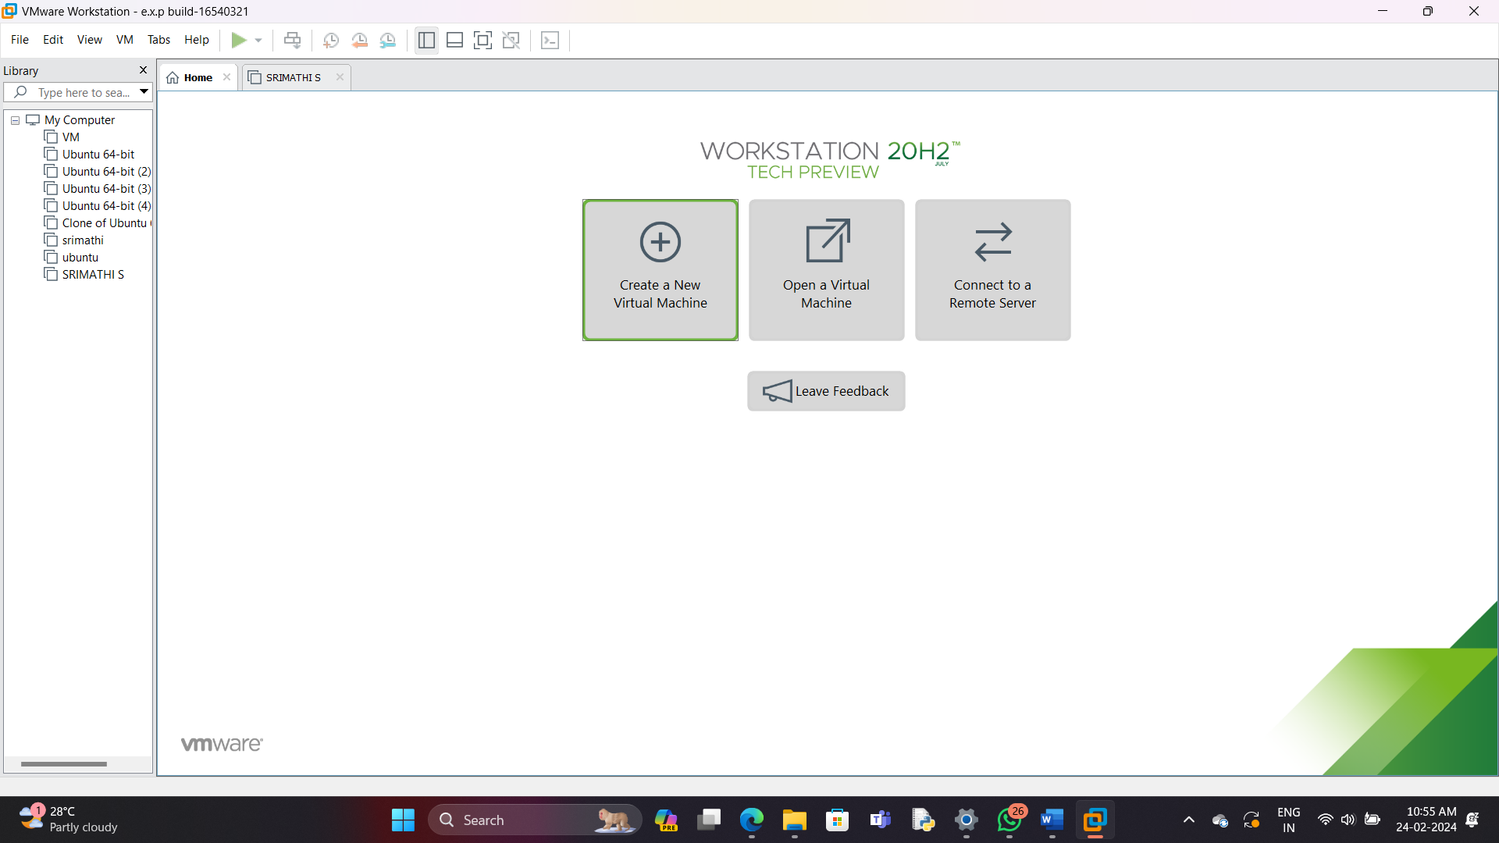

2

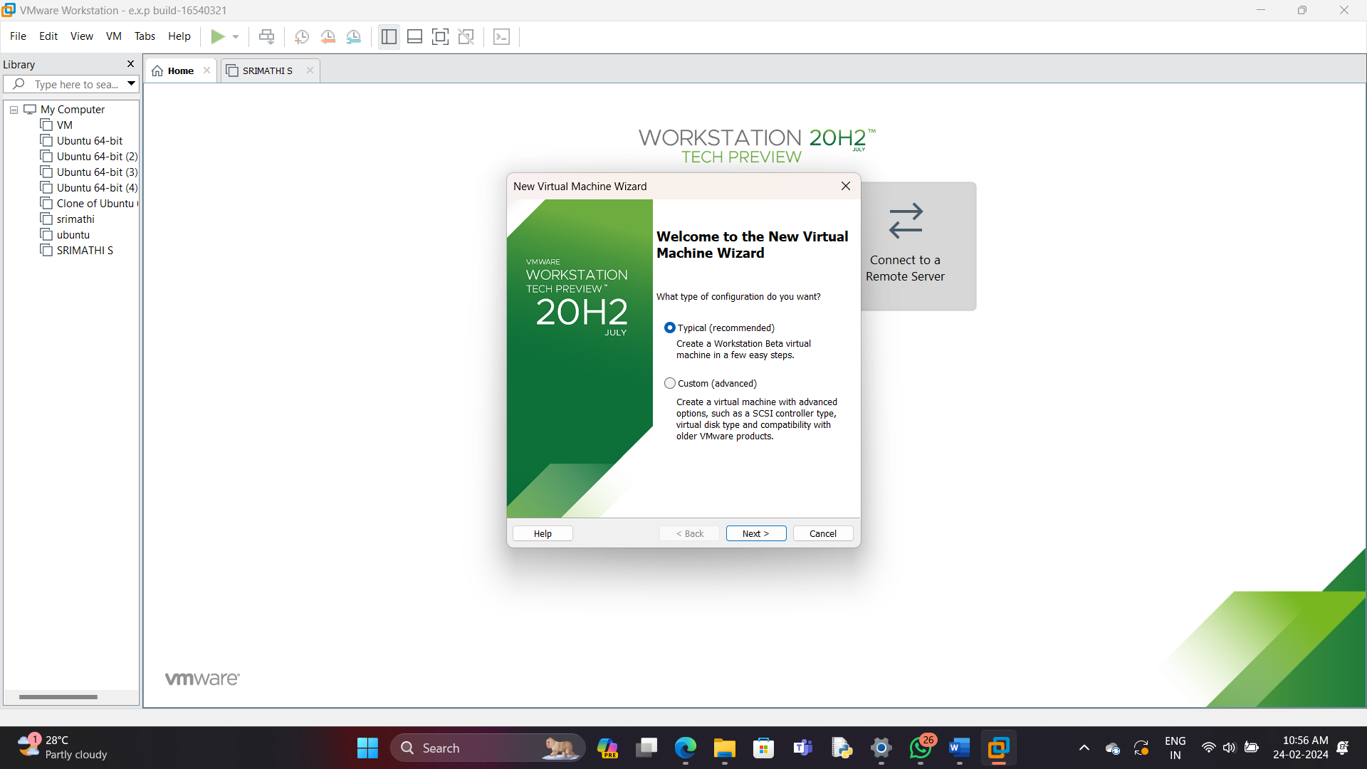

3

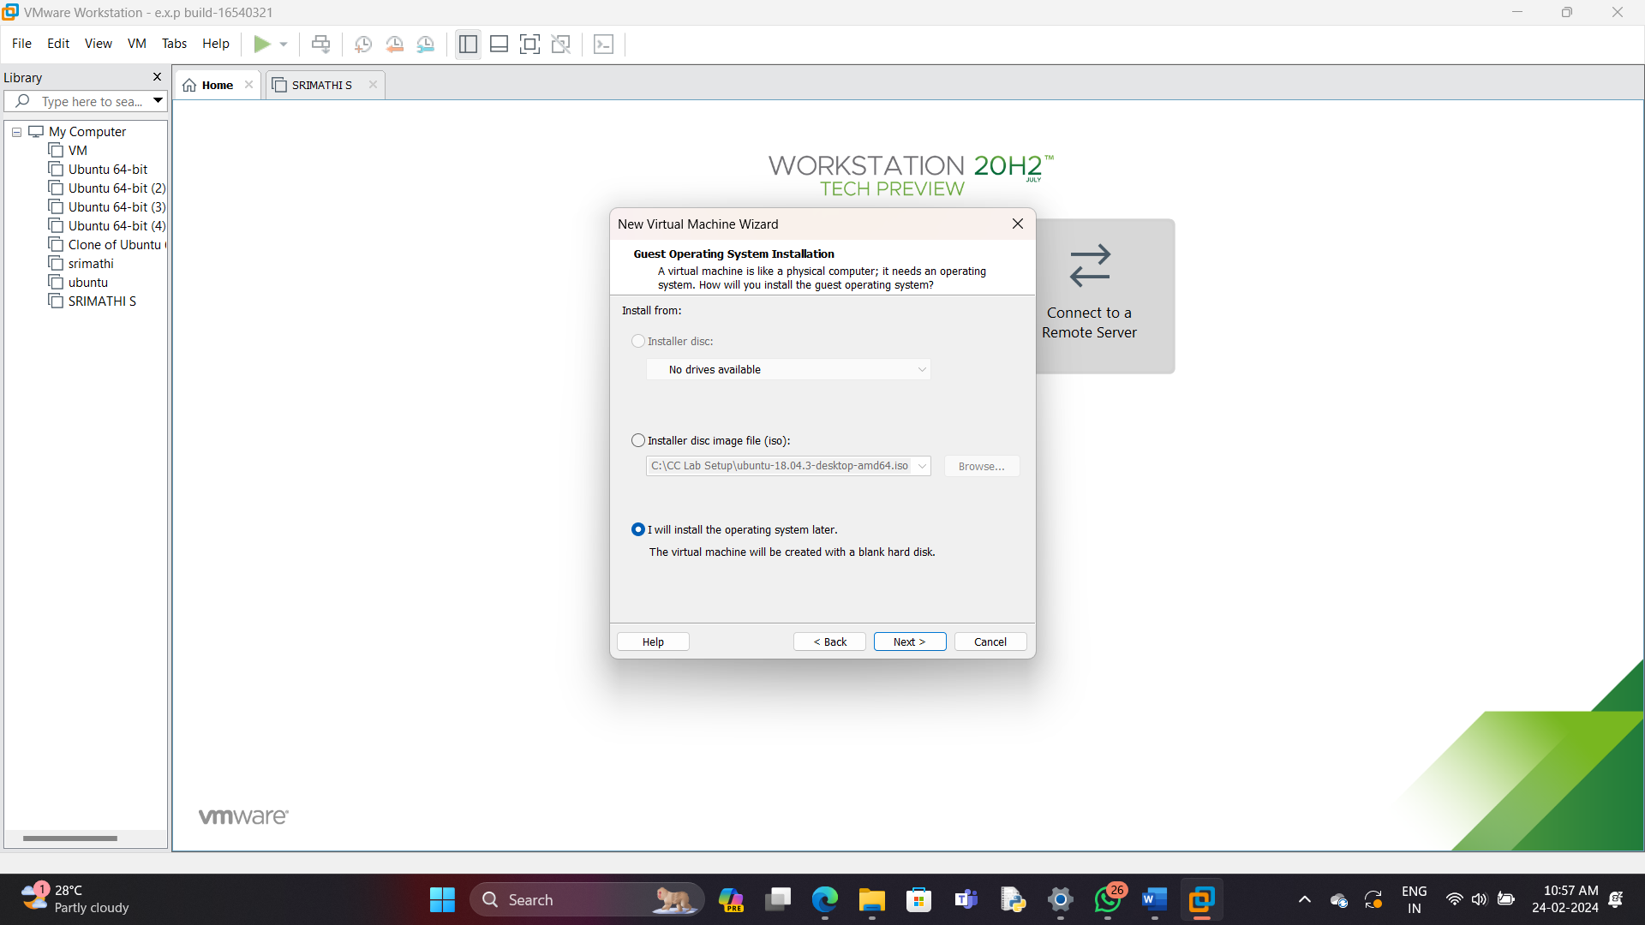4

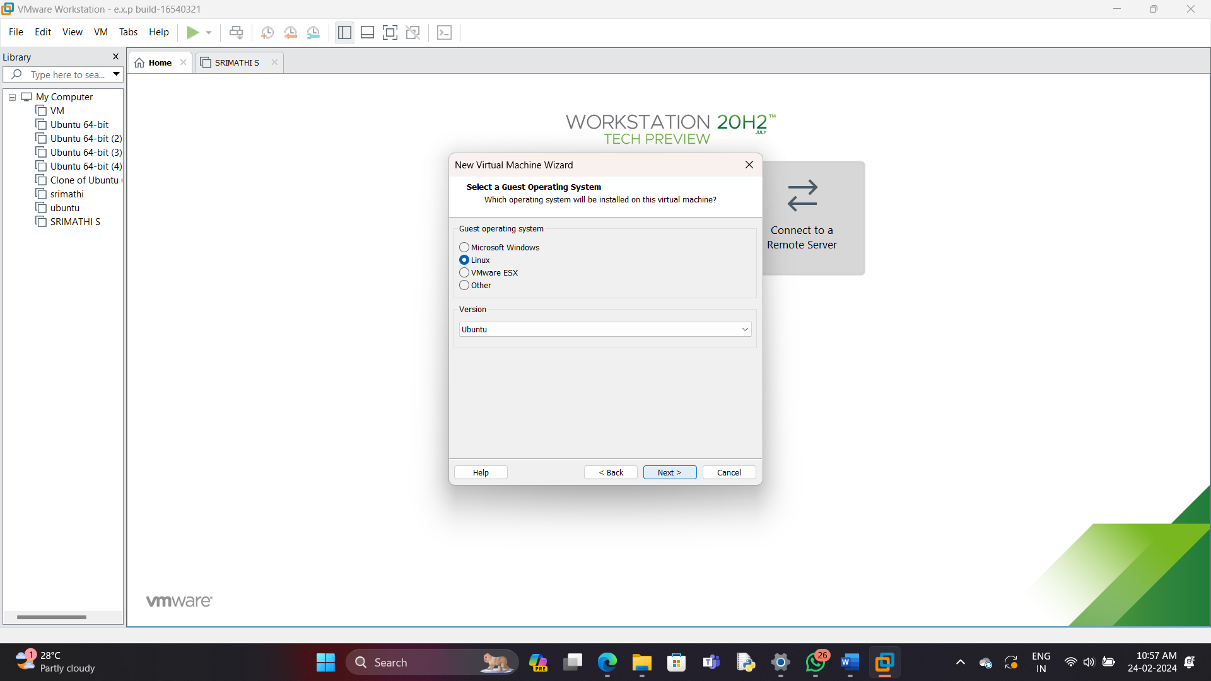

5 create a virtual machine named vm1

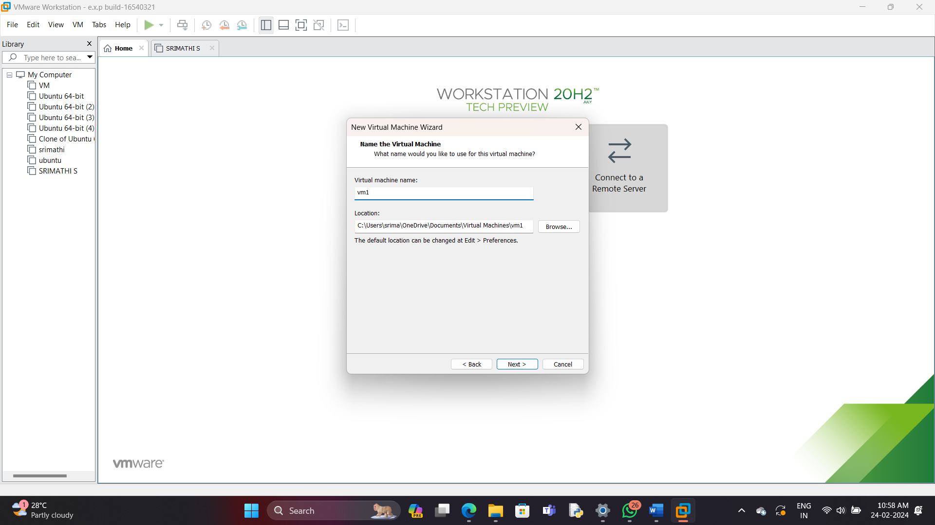

6

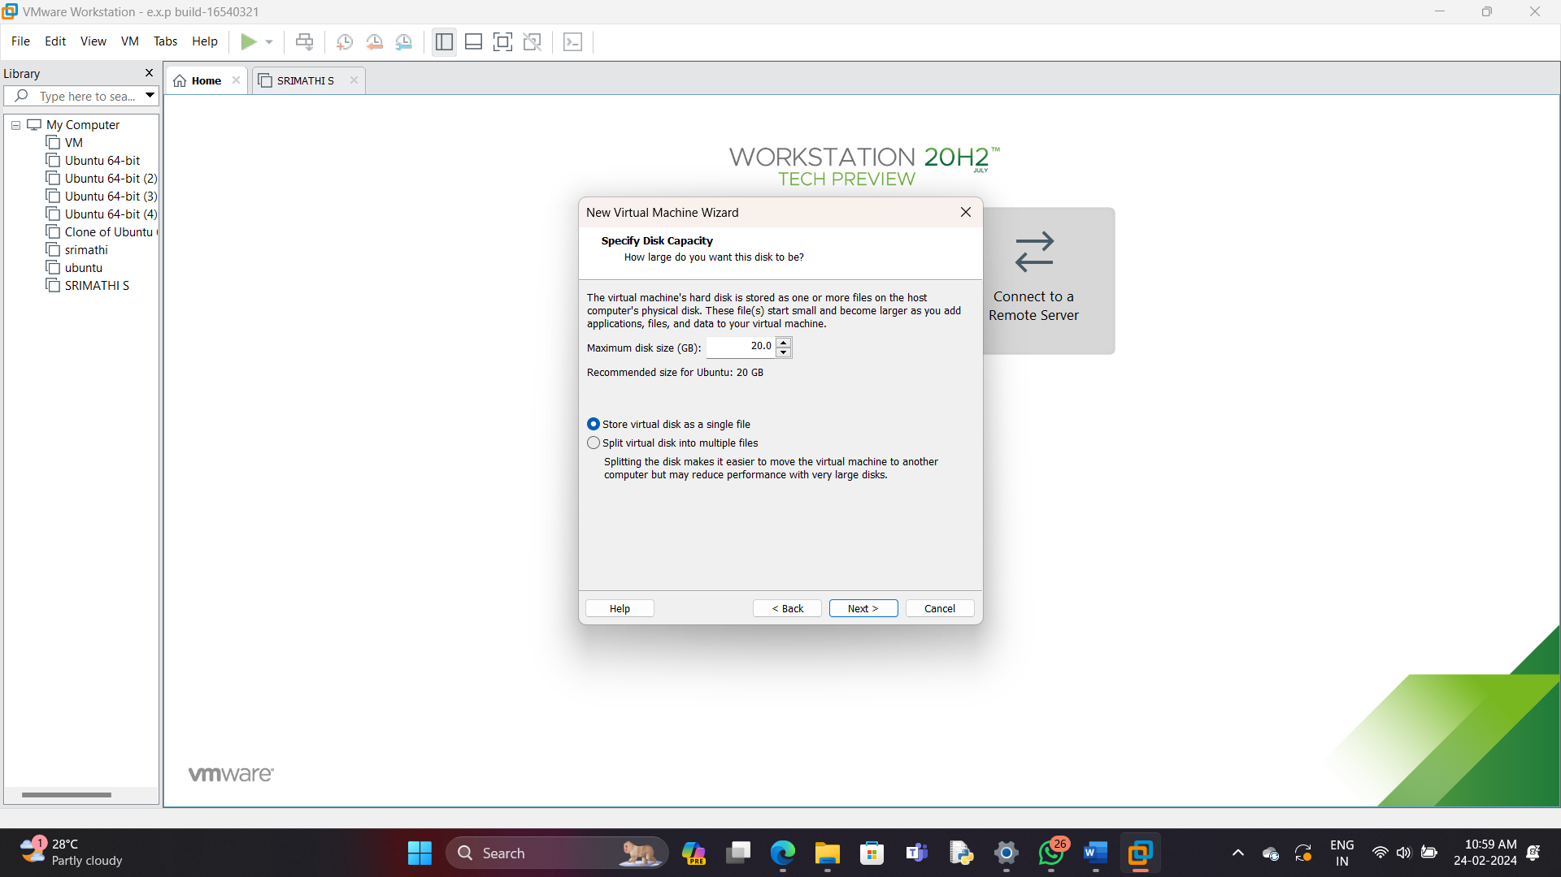

7

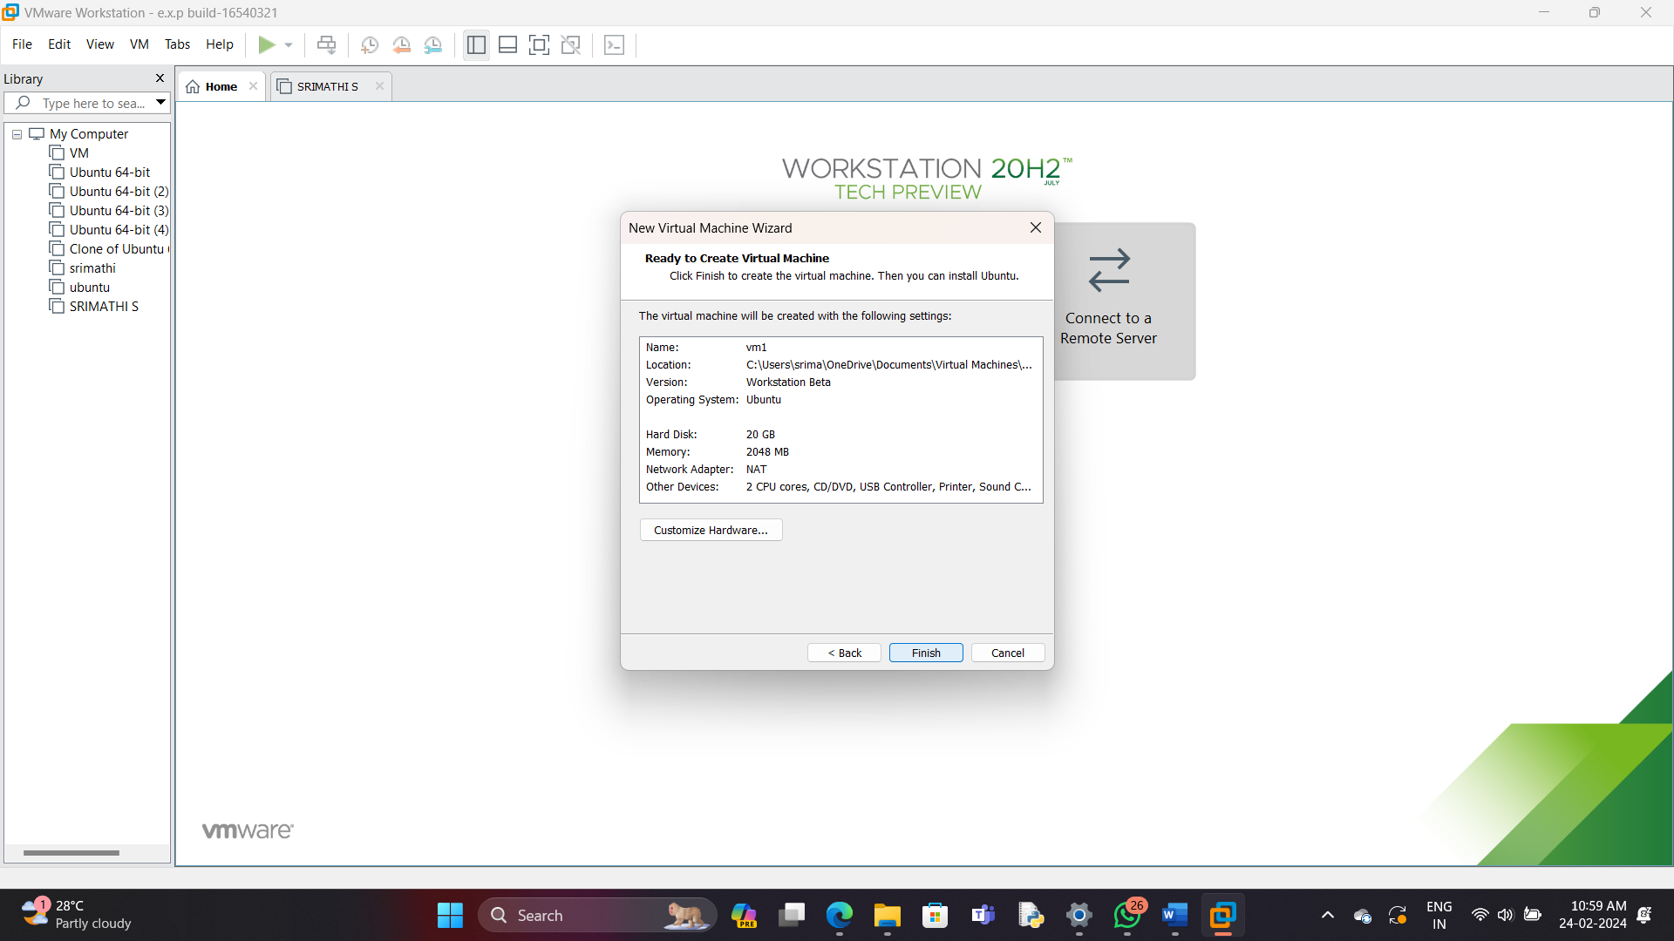

8 the virtual machine is created

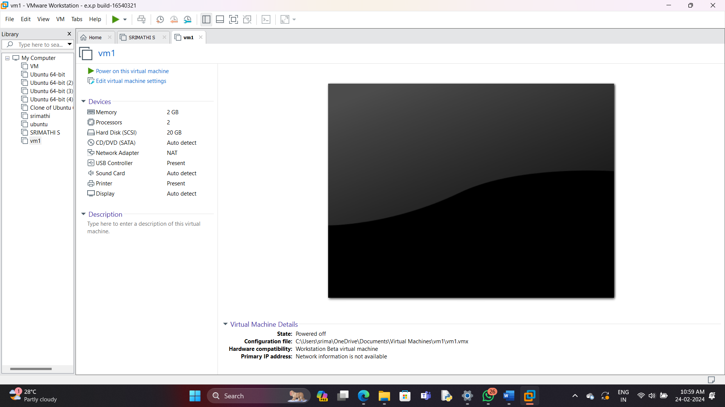

9. click manage and click clone

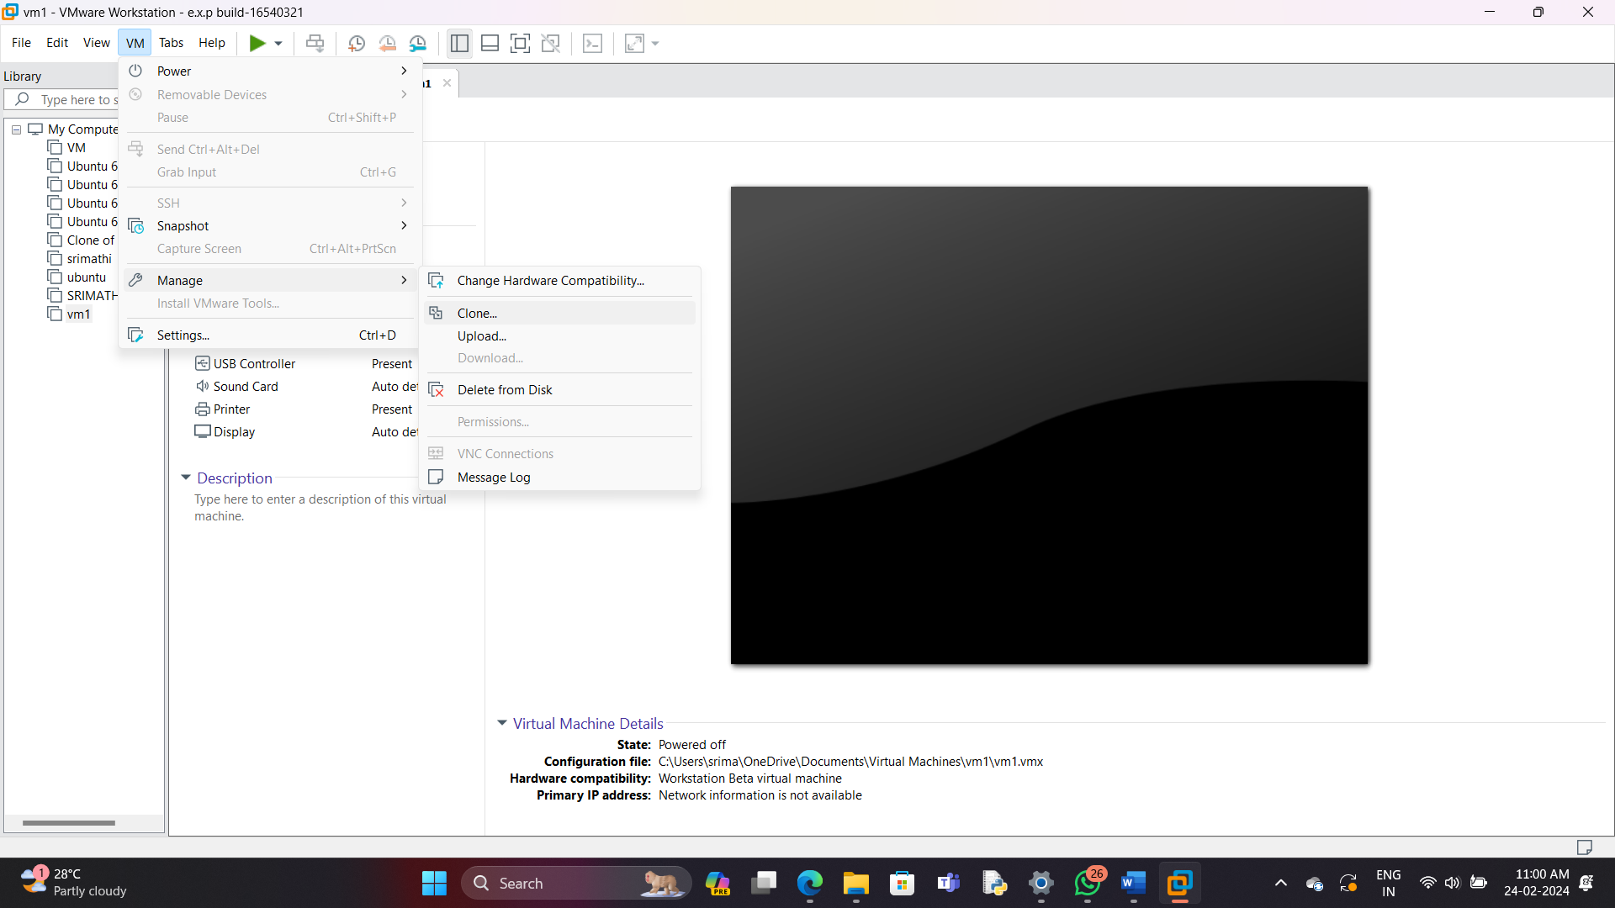10

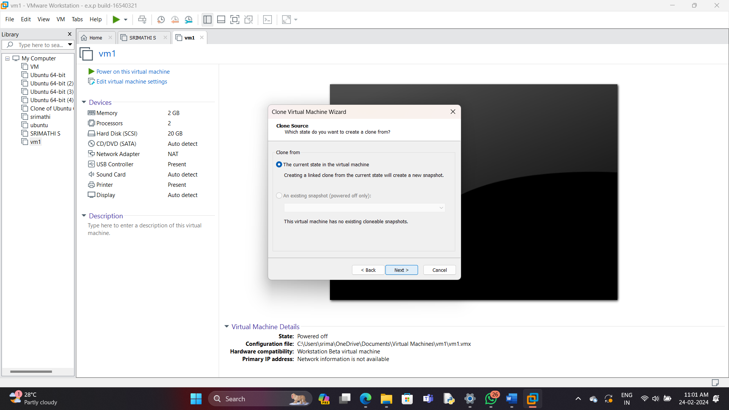

11.Give create full clone

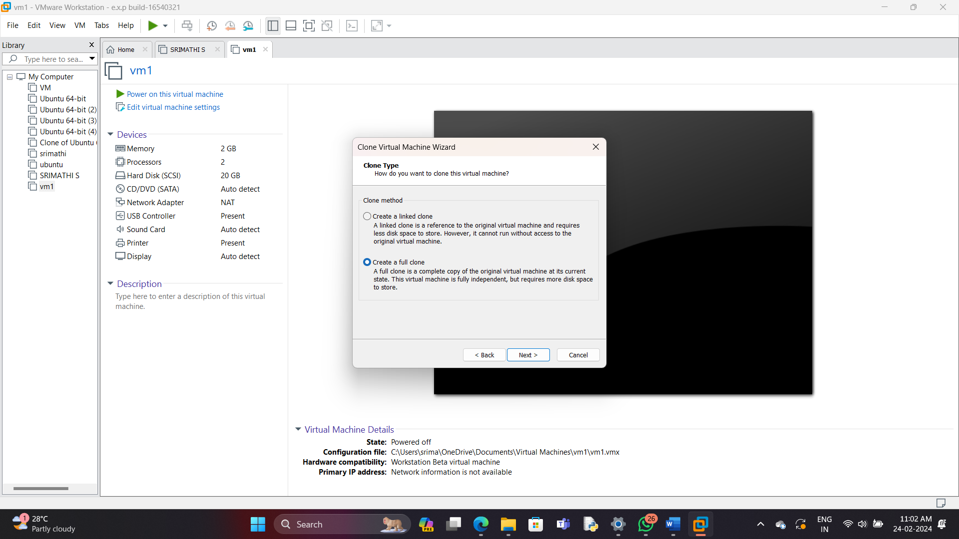

12

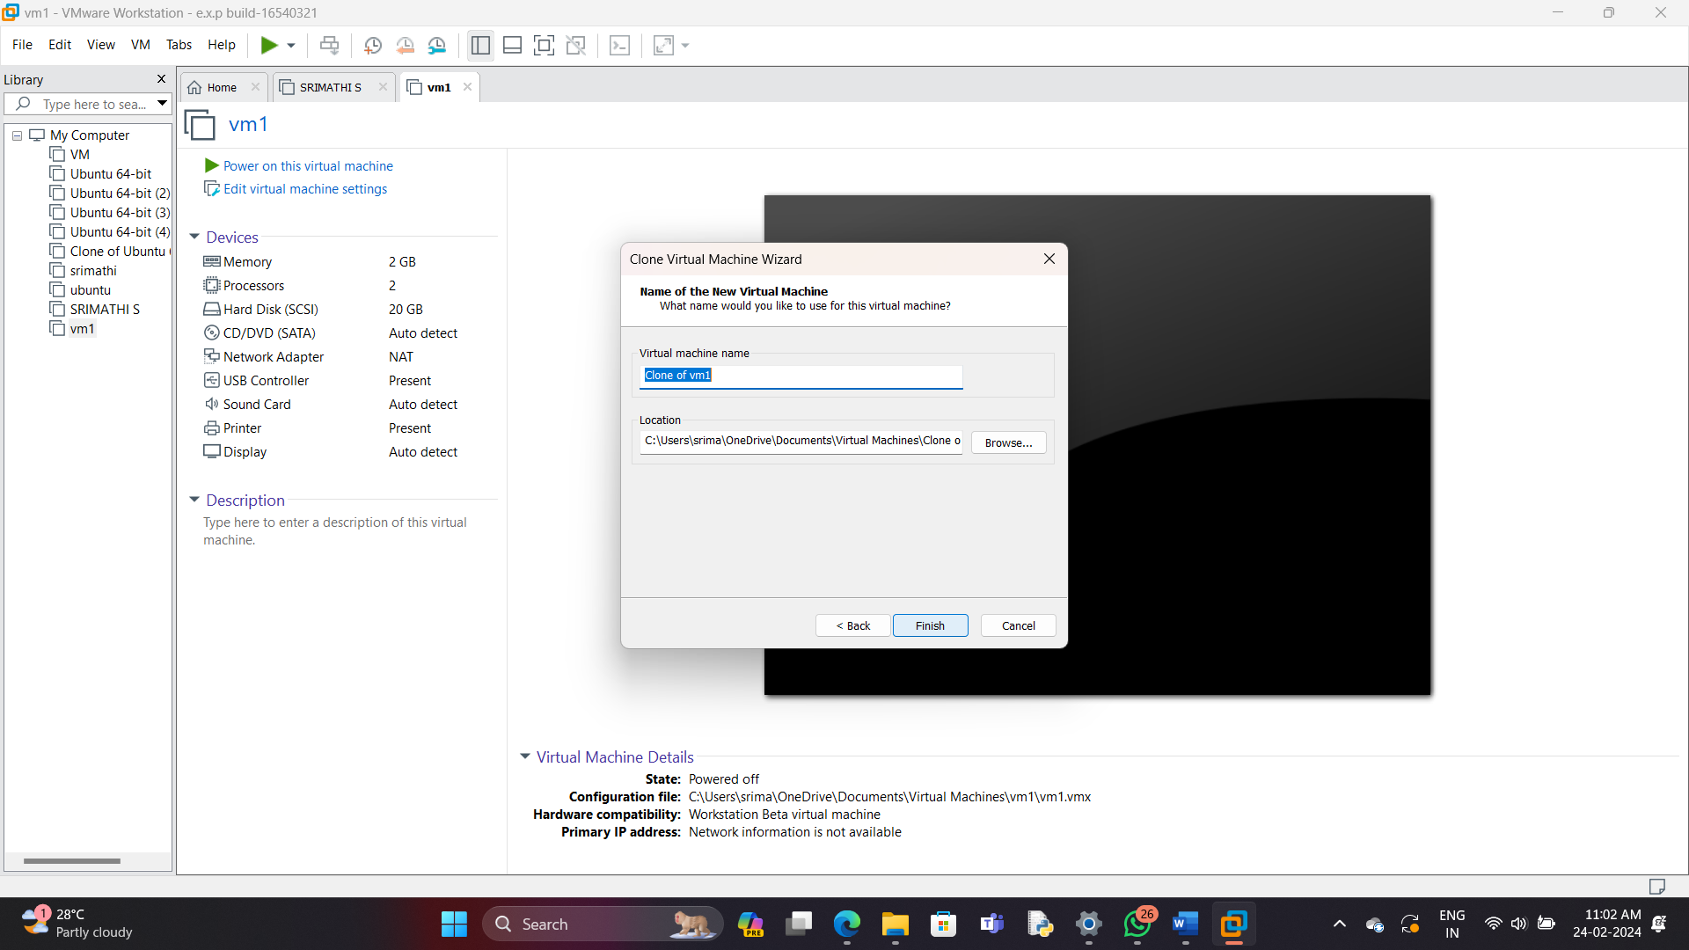

13

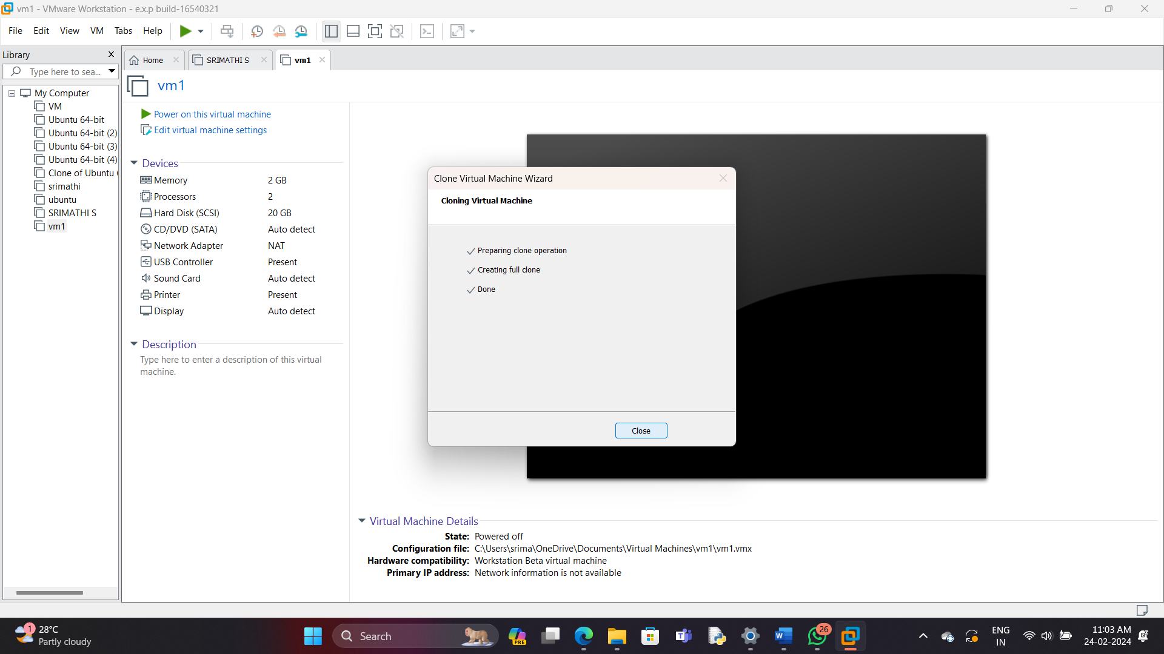

14.the clone of VM1 is created

